17.71: Using
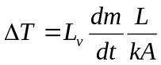
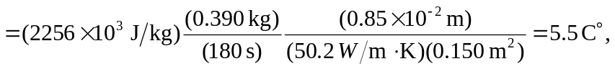
and the temperature of the bottom of the pot is 